**EMAIL TEMPLATE - Copy and paste all graphics and text to send to all campus/dept. employees**

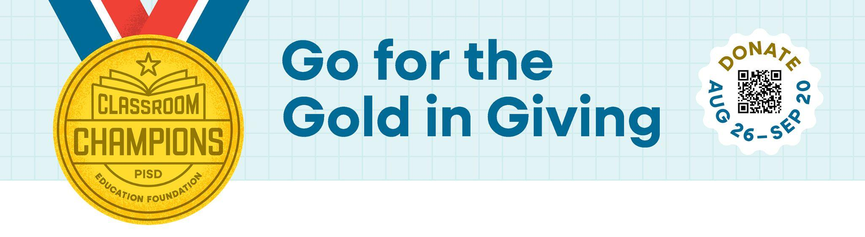

Dear Colleagues,

You are invited to be a Classroom Champion!

On behalf of the Plano ISD Education Foundation, thank you so much for all that you do for the students and families of Plano ISD!

The Education Foundation has officially launched the 2024 Employee Giving Campaign, and it runs from August 26 to September 20. Each year, they give nearly $300,000 in funding to programs that directly support us as Plano ISD staff members. Programs include the Employee Crisis Fund, CORE Store, Employee Wellness Program and Grants to Educators. The Education Foundation hopes to raise $100,000 during this campaign to help fund those efforts and support us as Plano ISD staff.

All donors contributing $40 or more, will receive a 2024 campaign t-shirt.



**NEW THIS YEAR FOR THE CAMPAIGN** - We can win fun prizes just for participating!

**Highest Participation:** This is calculated by percentage of staff who participate in the campaign by the last day of the campaign (for example, if there are 100 employees on a campus and 50 donate any amount to the campaign, it is a 50% participation rate). Prizes for the highest participation rate will be awarded in the following categories:

* Category 1: Head Start, early childhood schools & elementary schools
* Category 2: Middle schools, high schools & Academy High School
* Category 3: Senior high schools
* Category 4: Small departments (10 employees or less)
* Category 5: Medium departments (11-40 employees)
* Category 6: Large departments (41 or more employees)

The winning campuses and departments will receive the choice between a pizza party or a shaved ice party for staff members!

**Any Employee Who Donates**: All employees who donate any amount to the campaign by the last day of the campaign will be entered into a drawing for a Legacy West Staycation! One lucky winner will receive a package valued at $1,100 that includes:

* Two nights at the Renaissance Dallas at Plano Legacy West Hotel, $150 gift card to Del Frisco’s Double Eagle, $100 gift card to Legacy Hall, $100 gift card to J. Crew, $100 gift card to BAM Beauty Bar and $50 gift card to Sprinkles

## CALL TO ACTION

Make a financial contribution before September 20 to the PISD Education Foundation. This year’s Foundation campaign goal is $100,000 to benefit programs that benefit staff members.

## HOW TO GIVE

There are multiple ways to give to the campaign, so you can select the one that is the best fit for you. You can make a one-time contribution by credit card or check, or spread out your contribution over the school year with payroll deduction. Payroll deductions are spread out over 8 months (Oct. - May). Also, anyone that contributes $40 or more will receive an AWESOME t-shirt as a thank you, so they can show their support for the Plano ISD Education Foundation.

* **STEP 1:** Print out your Contribution Form. You can submit a check, a payroll deduction request or make your contribution online.**If contributing online, please be sure to still submit a contribution form along with your receipt to make sure you get credit for your donation and receive a t-shirt (if your gift is $40 or more).**
* **STEP 2:** Submit your completed form to me, your CAMPUS CAMPAIGN COORDINATOR, by **September 20.** We hope to have 100% participation, so any contribution would be greatly appreciated!

Thank you for your support of the Plano ISD Education Foundation!

Donations to the Plano ISD Education Foundation are not subject to recapture and are tax-deductible to the extent provided by law. Plano ISD does not directly or indirectly require or coerce employees to: 1) make or not make a contribution to a charitable organization or in response to a fundraiser; or 2) attend or not attend a meeting called for the purpose of soliciting charitable contributions.

